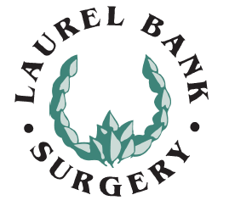
Flu Vaccinations 2020

Vaccine deliveries are expected from September, at which point eligible patients will be contacted and asked to book an appointment. These appointments are available using Patient Access online, or by telephoning Reception on 0113 2953900.

50-64 year old age group
The government has announced that this year’s flu vaccination will be made available to 50-64 year olds. Please note that people in the 50-64 year old age group will not be vaccinated until November and December at the earliest, providing there is sufficient vaccine, and no appointments will be offered for this age group until then. This is to ensure that those who are most at risk are vaccinated first. If you are aged 50-64 but fall into one of the other groups eligible for the flu vaccination, for example you have a health condition which puts you at risk from the flu, you will be invited earlier as detailed above.

Changes this year:
Due to the Covid-19 pandemic and Social Distancing requirements your flu appointment will seem a little different this year
- You will have to wear a face mask when attending your appointment
- Please do not arrive at the surgery early to help us control numbers and maintain social distancing
- The entrance to the surgery will be manned and once you have checked in you will be instructed where to wait until you are called for your appointment.
- Once you have checked in for your appointment please use the hand sanitizer provided
- You will be asked to minimise your time in the surgery to assist the flow of patients, you can help by wearing appropriate clothing to allow easy access to your arm and discarding any outer garments prior to entering the treatment room
- The clinicians will be wearing appropriate PPE at all times
- You will be asked to leave the surgery promptly after your appointment to minimise social contact
Thank you in anticipation of your cooperation.

